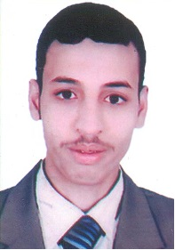
Personal Data
Name: | Ahmed Fathi Saber
Date and Place of Birth: | 7/2/1991,Assiut-Egypt
Nationality: | Egyptian
Institute: | Chemistry Department, Faculty of Science, Assiut University, Assuit, 71516 Egypt
Telephone: | 00201096844454 (Mobil)
Current Position: | Demonstrator
Marital status: | Married
Fields of Research: | Physicalorganic Chemistry
E-mail: | ahmed.fathi_91@yahoo.com

Education and Academic Qualifications:

2012 : Bachelor of Chemistry, Faculty of Science, Assiut University, Very good with honour grade .
2013 until present: Demonstrator, Chemistry Department, Faculty of Science, Assiut University.

